Week 2 Lab 5 Normalization

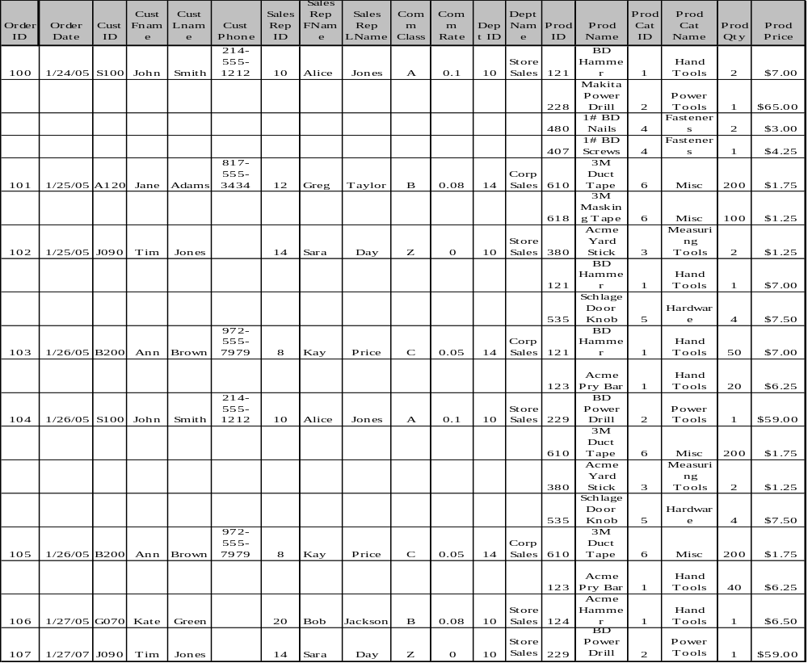

Additional Information:
Home Improvement Warehouse is a store that sells home improvement products. All orders are picked up from the store. Each order must be sold to a specific customer. Each customer must have at least one order associated with him/her, and each customer is assigned a specific sales rep. Each sales rep belongs to a specific department, but it is possible to have a department with no employees. Each sales rep is assigned to a commission class and earns the same commission rate for each of his/her sales, regardless of the sale amount or the department to which he/she belongs; but each commission class may have a different commission rate. It is possible to have a commission class to which no employees belong. Each product belongs to a single category, but some categories may not have products that belong to them.

Based on the information provided above and the data on the previous page, complete the following:

1. FIRST NORMAL FORM (1NF) – 15 points:
- Convert the table above to 1NF (double-click the table to access the data, eliminate repeating groups, then select and underline the appropriate PK).
- Show the table structure format (list the table name followed by its attributes, in parentheses, with the primary key underlined).
- Create a dependency diagram for the table above (primary key should be underlined).

2. SECOND NORMAL FORM (2NF) – 20 points:
- List each key component on a separate line, then write the original key on the last line.
- Show the table structure format for each table in 2NF.
- Create the dependency diagrams for the resulting tables.

3. THIRD NORMAL FORM (3NF) - 25 points:
- Convert to 3NF and show the table structure format for each table.
- Create the dependency diagrams for the resulting tables.

4. ENTITY-RELATIONSHIP MODEL - 30 points:
- Using Chen notation, create an ERD showing all of the 3NF tables above. You must show the entities, relationships, connectivity, participation, and cardinality (it is not necessary to show the attributes on the ERD).
- Based on the ERD created in step 4a, use Microsoft Access to create a relational schema showing the entities, their attributes, and the connectivity of the relationships. The PKs must be underlined or highlighted.

5. BUSINESS RULES – 10 points:
Write business rules to identify and describe the relationships among the entities. Each pair of business rules will have the following format:
Each A is {sometimes | always} related to {one | one or more} B's.
Each B is {sometimes | always} related to {one | one or more} A's.

